How to Apply for Graduation

- Log into your student’s portal.
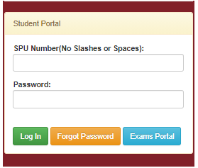

- Click on Graduation
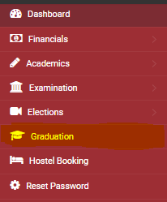

- Fill in the graduation form.
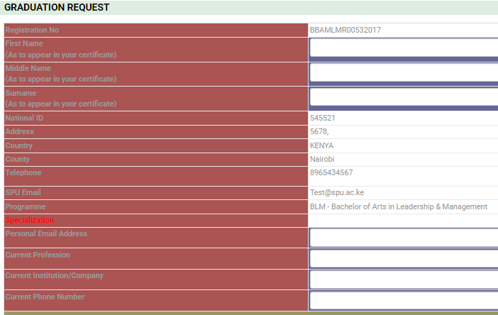

- Click on the box to confirm the names you have typed in this form are as will appear on your certificate.

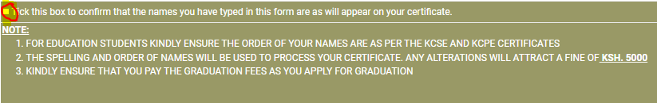

- Read and understand the information in the NOTE: before clicking on APPLY TO GRADUATE
